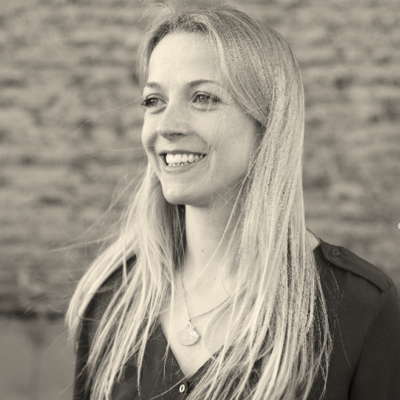
IZZY CHARMAN
Writer and series/ executive producer

izzy@izzycharman.com
T: 07980 858202

BAFTA-nominated TV producer/ writer with 15 years’ experience in developing & making factual films for UK, US, European broadcasters and cinema release, and writer of non-fiction books

TV AND FILM CREDITS INCLUDE:

Series Producer, The Biggest Dig (w/t)
Lion Television 4 x 1 hour for BBC2, TX TBC 2020

- Long-term access project following Britain’s biggest ever archaeological dig
- This presenter-led, landmark series will use archaeology, historical research and cutting edge science to tell an epic history of Britain
- I oversaw the conceptual development and initial pitch, and managed the access, research and initial filming over 2017/18 (prior to going on maternity leave)

Series Producer, Inside the Tower of London
Lion Television 4 x 1 hour for Channel 5, TX October 2019

- Huge ratings success for the channel: one of the highest rating shows of 2018
- With access to the Tower of London’s curatorial and yeomen warder (aka beefeater) teams, the series combined historical and observational genres to tell the story of the Tower of London, past and present
- I managed the access to the Historic Royal Palaces team and organised multi-team filming schedules and stories/ content across the four episodes
- I oversaw the edits and final post and took responsibility for cutting two of the episodes

Co-executive Producer, The Making of Marc Bolan
Lion Television 1 x 1 hour for Sky Arts, TX Sept 2017

- I developed this one-off film to coincide with the 40th anniversary of Marc Bolan’s death
- I helped the director to plan the interview and GV shoots and give the film a distinctive and cinematic tone
- I oversaw the edit, helping particularly with the scripting and narrative structure

Researcher, Labour Party Election Broadcasts (May 2017)
Sixteen Films 4 x short films (Director: Ken Loach, Writer: Paul Laverty)

- I worked with Loach and Laverty to produce these short films, helping to develop ideas and sourcing all the spokespeople/ voices in them

Writer, Tear Down and Rebuild (Winner of the MAC International Ulster Bank Award)
Final film of artist Jasmina Cibic’s Spielraum trilogy (2015), exhibited and screened internationally

- Winner of the prestigious MAC International award, this film by artist Jasmina Cibic, filmed in the Palace of the Federation in Belgrade, explores the ideas of architecture and state power
- I wrote the script, which was a dialogue between four symbolic female characters, composed entirely of quotes from political speeches, debates and proclamations on art and architecture

Producer and writer, The Great War: The People’s Story (BAFTA-nominated, BANFF winner)
ITV Studios in association with The Imperial War Museum
4 x 1 hour for ITV 1, TX August 2014 (Exec: Ollie Tait)

- Prime-time drama-doc series to mark the centenary of the outbreak of WW1
- A fantastic cast (Alison Steadman, Danny Mays, Brian Cox, James Norton, Myanna Buring) recreate ordinary people’s lives during the war, based on their first-hand accounts
- I did all the archive research and managed the association with the Imperial War Museum, (I also worked in other archives/ private collections across the UK) to find a cast of characters to reflect Britain and whose stories could be woven together to tell the story of the conflict.
- I wrote the shooting scripts for the drama, produced all four episodes and edit produced one
- I also wrote a book to accompany the series – see below
Researcher, plus edit director for online/ DVD extras, The Spirit of 1945 (BIFA-nominated)
Sixteen Films, feature doc, International theatrical release 2013 (Director: Ken Loach)

- Feature doc exploring the 1945 Labour government and their rebuilding of Britain through a programme of common ownership and welfare provision – and the contrasting picture today.
- I worked with Loach to find and film the contributors and research the content for the film.
- I also produced all the content for the accompanying digital project, directing the edit of over five hours of footage for a DVD sold with the feature, and for the online project.

Producer, Words of Captain Scott (RTS-Nominated)
ITV Studios, 1 x 1 hour ITV1, TX March 2012 (Director: Paul Copeland, exec: Ollie Tait)

- Stylised drama-doc telling the story of the tragic Scott Expedition to the South Pole – and the successful Norwegian expedition - through first-hand accounts, brought to life by actors
- I did all the research and worked closely with the director to write the script
- Talent featured included Dougray Scott, Alistair McGowan and Lars Mikkelsen

Director/ Producer, Heath-Wilson: The Duel
Telesgop, 1 x 90 minutes for BBC4, TX May 2011 (Exec: Simon Berthon)

- Feature length documentary about Edward Heath and Harold Wilson. The film brings to life the turbulent era in which they governed through the prism of their personal rivalry.
- Interviewees include: Douglas Hurd, Geoffrey Howe, Dennis Healey, Neil Kinnock

‘Tremendous” (The Times); “utterly engaging viewing” (The Mail); “this expert documentary” (The Telegraph); “a fascinating insight” (Time Out)

Associate Producer, Words of the Blitz (RTS-nominated)
ITV Studios, 1 x 1 hour ITV1, TX Sept 2010 (Director: Paul Copeland, exec: Ollie Tait)

- Stylised documentary telling the story of the Blitz through a wide range of first-hand accounts, brought to life by actors
- I did all the research and worked closely with the director to write the script
- Talent featured included Dominic West, Romola Garrai, Sheila Hancock, Russell Tovey), the accounts’ authors, and present-day equivalents (nurses, soldiers etc.)

"Poignant, gripping and impressively produced“ (The Mail); "understated and arresting." (Time Out)

Associate Producer, The Last Nazis: Most Wanted
Minnow Films, BBC2, TX Sept 2009 (Director: Charlie Russell, execs: Simon Berthon and Morgan Matthews)

- Authored obs doc, which follows me and the director, Charlie Russell, as we search for, and spend time with, some of the last surviving participants in the Nazi Regime.

“An astounding if highly uncomfortable insight” (The Times); “The female half of the pairing is pretty impressive: bright, inquisitive and a dab hand at handling tricky situations.” (Time Out)

Assistant Producer, The Queen (eps 1 and 2)
Blast Films, 5 x 1 hours for C4 & ABC, TX Nov 2009 (Director: Peter Nicholson, exec: Ed Coulthard)

- Historical drama-doc series (with scripted drama, archive and interviews) looking at the changing face of Britain through the prism of the monarchy

Assistant Producer, Nuremberg: Goering’s Last Stand (BAFTA award winner, 2007)
3BM TV, 1 x 2 hours for C4 and The History Channel, TX August 2006 (Director: Peter Nicholson)

- Feature length drama-doc bringing to life the Nuremberg Trial - beyond the courtroom
- I researched all the primary source material that was used in the drama script and worked closely with the director to write the script and bring it to life appropriately, helping to organise and oversee a massive drama shoot in a London studio and on location in Ireland

DEVELOPMENT EXPERIENCE INCLUDES:

I have worked extensively in factual TV development, for companies including Blakeway, Blast, Raw, Lion Television, Wild and many more. I have also worked on drama/ feature film projects in development with Big Talk (director Joe Cornish), See Saw, Fly Films (director Samantha Morton) ITV Studios (with head of continuing drama John Whiston) and Element Pictures.

NON-FICTION BOOKS (as Isobel Charman):

The Zoo: The Wild and Wonderful Tale of the Founding of London Zoo
Penguin/ Viking (Nov 2016) in the UK/ Commonwealth and Pegasus Books (April 2017) in the US

- Based on extensive research in the ZSL archives and beyond, this book pieces together the founding and first 25 years of London Zoo (1826-1851), telling the story through the eyes of key protagonists from the keepers to taxidermists to Charles Darwin
- Featured on BBC radio 2 and radio 4, BBC History and New York Times podcasts, Hay and Richmond Literary Festivals etc.

“An impressive work of imagination and research… a pleasure to read” (The Guardian), “Extraordinary” (Sunday Times), “Astonishing” (Daily Mail), “Delightful” (Nature), “Charming” (Evening Standard), “Vivid, entertaining and scrupulously researched” (New York Times)

The Great War: The Nation’s Story
Published in the UK/ Commonwealth by Random House/ Arrow (July 2014)

- Major publication to accompany the BAFTA-nominated ITV series
- Expanding the content of the series, it used interwoven personal histories to tell the story of the First World War (the home front and fighting fronts) from a human perspective.

“Deeply moving, fascinating and powerful” (Sunday Mirror), “a handful of people dominate this wonderful book… their stories will haunt you for a long time” (Scottish Herald)

EDUCATION:

2000 - 2003 | Bristol University | - BA (Hons) 1st Class in History  - George Hare Leonard prize (best degree), Gardenhurst Prize (best 2nd year results), Arts Faculty scholarship
1998 - 2000 | Brighton, Hove and Sussex Sixth Form College | - 5 A-levels: 5 grade As (3 within top 5 people nationally)

